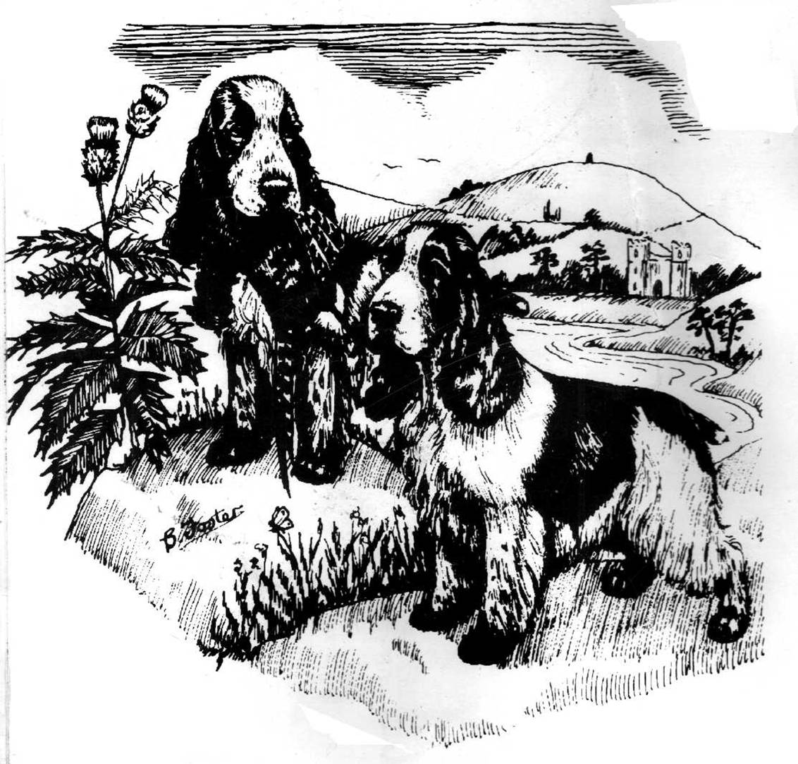
The Cocker Spaniel Club of Scotland- Membership Application
Established 1933

PLEASE PRINT IN BLOCK CAPITALS

NAME: MR/MRS/MISS

ADDRESS:

POSTCODE: PHONE NO:

EMAIL:

KENNEL AFFIX/PEDIGREE (if any):

If my membership is accepted I agree to abide by the clubs code of eithics

SIGNATURE(S) DATE

Proposed by : (name) Signature

Seconded By(name) Signature

Please print and complete this form and send with the appropriate fees:
£8.00 for single MEMBERSHIP
£10.00 for joint membership
£1.00 FOR JUNIOUR MEMBERSHIP
TO: Mrs Catherine Mason, Woodburn Cottage, Farnell, By Brechin, DD9 6TW
PLEASE MAKE CHEQUES/POSTAL ORDERS PAYABLE TO “THE COCKER SPANIEL CLUB OF SCOTLAND”

DATA PROTECTION PLEASE NOTE YOUR DETAILS WILL BE KEPT ON FILE FOR THE CLUBS RECORDS AND WILL NOT BE USED FOR ANY OTHER purpose

Office use only:

